

| Submitted By: | Kriston Jomari (231165R) |
| --- | --- |
|  | Wong Jun Lin (242844E) |
|  | Lim Wei Yi, Markus (240785A) |
|  | Kiew Hein Royce (231003P) |
| Module Group: | IT1393-02 |
| Tutor: | Ms. Sally Tang |
| Submitted on: | 08/12/2024 |



# Part 1: Defining Database Structure and Objects using Database Definition Language (DDL) for KeithsBike database (50 marks)

**Task 1: Develop DDL statements for creating the tables in the KeithsBike Database**

The initial DDL statements used.

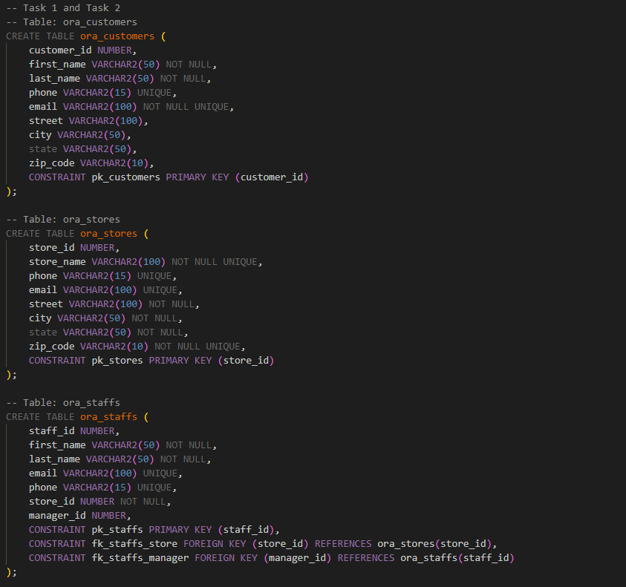

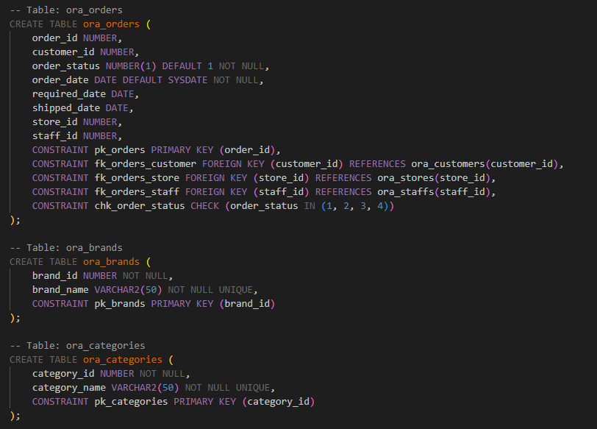

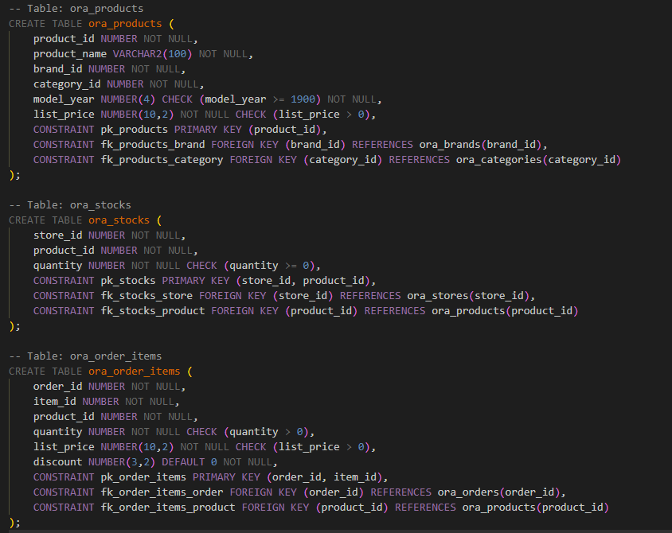

In Oracle APEX, visit SQL Workshop > SQL Scripts > Upload > Run > Run Now

Proof showing that all nine statements were successfully created:  
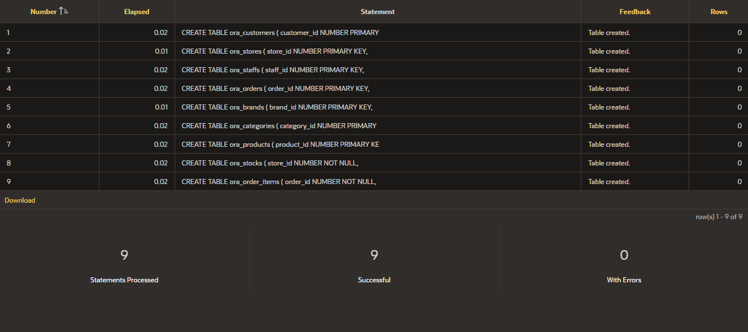

Testing with SELECT * FROM user_tables; provides us a list of all nine tables.  
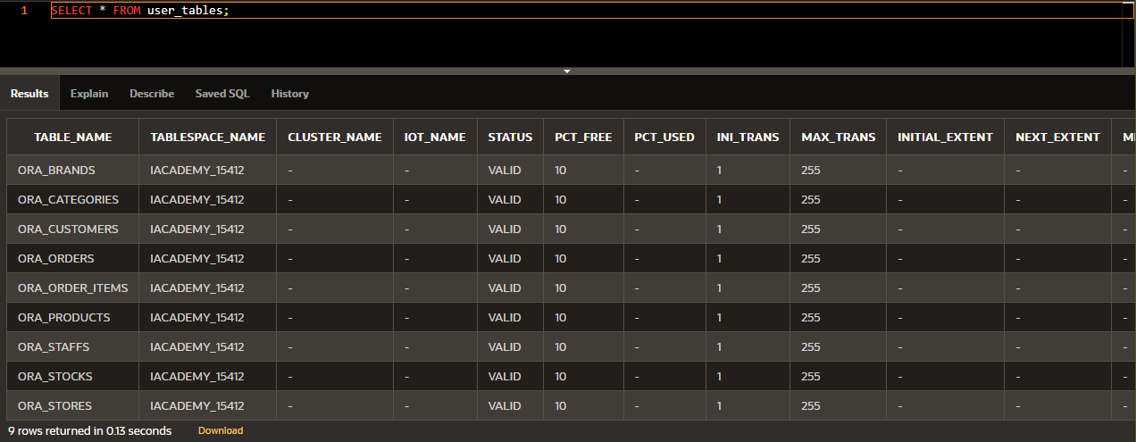

**Assumptions Made:**

1. **The stores are located in the**

**Task 2: Creating and Managing Constraints**

1. Adding the different constraints.  
   1. Primary Key (PK) and Foreign Key (FK) constraints

All relevant PKs and FKs were predefined in the script in Task 1. Below are the relevant snippets of code:

ora_customers  
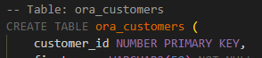

ora_orders  


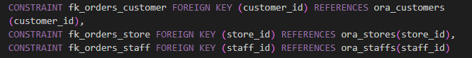

ora_staffs  




ora_stores  


ora_order_items  
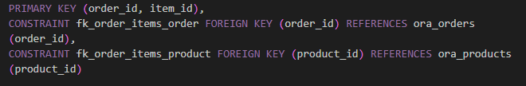

ora_categories  


ora_products  


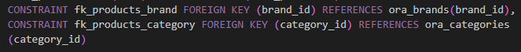

ora_stocks  
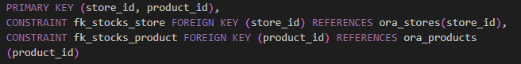

ora_brands  


* 1. Unique (UQ) and Not Null (NN) columns with explanation (might not be accurate as changes made)

| Table | Column | UQ | NULL Allowed | Explanation |
| --- | --- | --- | --- | --- |
| **ora_customers** | customer_id | ✔ | ✘ | Each customer must have a unique ID (Primary Key). |
|  | first_name | ✘ | ✘ | Every customer needs a first name. |
|  | last_name | ✘ | ✘ | Every customer needs a last name. |
|  | phone | ✔ | ✔ | Phone numbers are optional but must be unique. |
|  | email | ✔ | ✔ | Emails are required and must not repeat. |
|  | street | ✘ | ✔ | Address is optional. |
|  | city | ✘ | ✔ | City is optional. |
|  | state | ✘ | ✔ | State is optional. |
|  | zip_code | ✘ | ✔ | Zip code is optional. |
| **ora_orders** | order_id | ✔ | ✘ | Each order must have a unique ID (Primary Key). |
|  | customer_id | ✘ | ✘ | Every order must belong to a customer. |
|  | order_status | ✘ | ✘ | Status is required and defaults to "1" (Pending). |
|  | order_date | ✘ | ✘ | Defaults to today if not explicitly given. |
|  | required_date | ✘ | ✔ | Required delivery date is optional. |
|  | shipped_date | ✘ | ✔ | Shipping date is optional until shipped. |
|  | store_id | ✘ | ✘ | Orders must come from a store. |
|  | staff_id | ✘ | ✔ | Staff ID is optional if no staff is assigned. |
| **ora_staffs** | staff_id | ✔ | ✘ | Each staff member must have a unique ID (Primary Key). |
|  | first_name | ✘ | ✘ | Every staff member needs a first name. |
|  | last_name | ✘ | ✘ | Every staff member needs a last name. |
|  | email | ✔ | ✔ | Email is optional but must be unique if provided. |
|  | phone | ✔ | ✔ | Phone is optional but must be unique if provided. |
|  | store_id | ✘ | ✘ | Every staff member must belong to a store. |
|  | manager_id | ✘ | ✔ | Manager is optional for top-level staff. |
| **ora_stores** | store_id | ✔ | ✘ | Each store must have a unique ID. |
|  | store_name | ✘ | ✘ | Store name is required. |
|  | phone | ✔ | ✔ | Phone is optional but must be unique if provided. |
|  | email | ✘ | ✔ | Email is optional. |
|  | street | ✘ | ✘ | Address is required. |
|  | city | ✘ | ✘ | City is required. |
|  | state | ✘ | ✘ | State is required. |
|  | zip_code | ✔ | ✘ | Zip code is unique and is required. |
| **ora_products** | product_id | ✔ | ✘ | Each product must have a unique ID (Primary Key). |
|  | product_name | ✘ | ✘ | Every product needs a name. |
|  | brand_id | ✘ | ✘ | Every product must belong to a brand. |
|  | category_id | ✘ | ✘ | Every product must belong to a category. |
|  | model_year | ✘ | ✔ | Year is optional. |
|  | list_price | ✘ | ✘ | Price is required and must be greater than 0. |
| **ora_categories** | category_id | ✔ | ✘ | Each category must have a unique ID. |
|  | category_name | ✔ | ✘ | Every category needs a unique name. |
| **ora_brands** | brand_id | ✔ | ✘ | Each brand must have a unique ID. |
|  | brand_name | ✔ | ✘ | Every brand needs a unique name. |
| **ora_order_items** | order_id | ✘ | ✘ | Must reference an existing order (Part of PK). |
|  | item_id | ✘ | ✘ | Unique within each order (Part of PK). |
|  | product_id | ✘ | ✘ | Every order item must have a product ID. |
|  | quantity | ✘ | ✘ | Quantity is required and must be more than 0. |
|  | list_price | ✘ | ✘ | Price is required and must be greater than 0. |
|  | discount | ✘ | ✔ | Discount is optional and defaults to 0. |
| **ora_stocks** | store_id | ✘ | ✘ | Must reference an existing store (Part of PK). |
|  | product_id | ✘ | ✘ | Must reference an existing product (Part of PK). |
|  | quantity | ✘ | ✘ | Quantity is required and must be at least 0. |

* 1. CHECK constraint to ensure price is > $0.00 (also implemented in Task 1).

CHECK constraint on list_price in ora_products.

list_price NUMBER(10,2) NOT NULL CHECK (list_price > 0)

* 1. CHECK constraint to restrict order_status values.

CHECK constraint on order_status in ora_orders.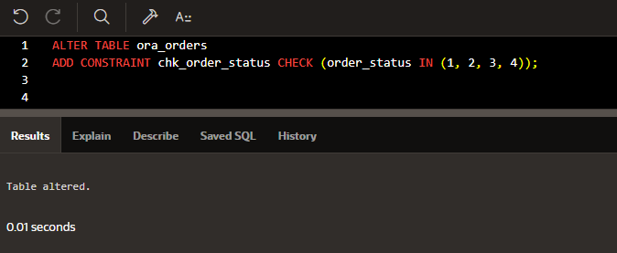

For checking.  
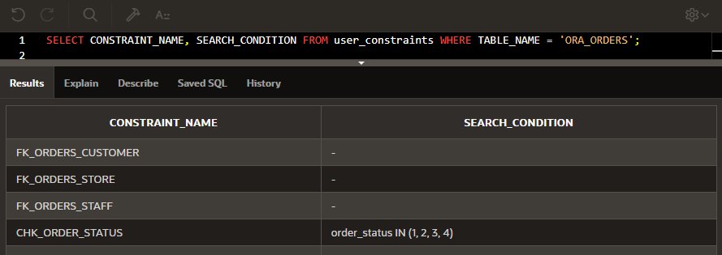

**Task 3: Working with Sequences (Indexes and Synonyms) & View**

1. Use a sequence to generate PKs for the Customers table beginning from 1001 and increment by 1. We used:

CREATE SEQUENCE customer_id_seq START WITH 1001 INCREMENT BY 1;

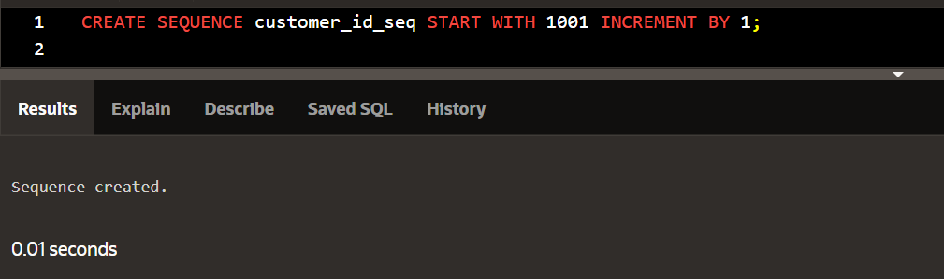

Check with:

SELECT SEQUENCE_NAME, MIN_VALUE, MAX_VALUE, INCREMENT_BY, LAST_NUMBER

FROM user_sequences

WHERE SEQUENCE_NAME = 'CUSTOMER_ID_SEQ';

Results:

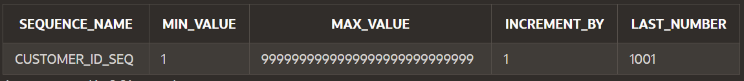

1. Use a sequence to generate PKs for Staffs table starting at 2001 and increment by 1. We used:

CREATE SEQUENCE staff_id_seq START WITH 2001 INCREMENT BY 1;

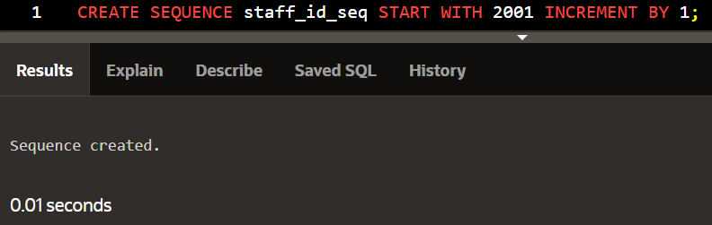

Check with:

SELECT SEQUENCE_NAME, MIN_VALUE, MAX_VALUE, INCREMENT_BY, LAST_NUMBER

FROM user_sequences

WHERE SEQUENCE_NAME = 'STAFF_ID_SEQ';

Results

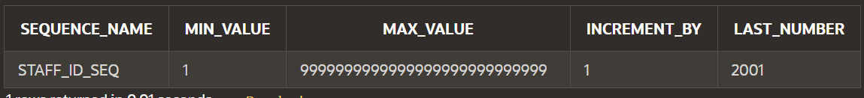

1. Add the data to the tables using INSERT statements.

Brands:

-- Insert records into ora_brands

INSERT INTO ora_brands (brand_id, brand_name)

VALUES (1, 'Electra');

INSERT INTO ora_brands (brand_id, brand_name)

VALUES (2, 'Haro');

INSERT INTO ora_brands (brand_id, brand_name)

VALUES (3, 'Heller');

INSERT INTO ora_brands (brand_id, brand_name)

VALUES (4, 'Pure Cycles');

Proof:

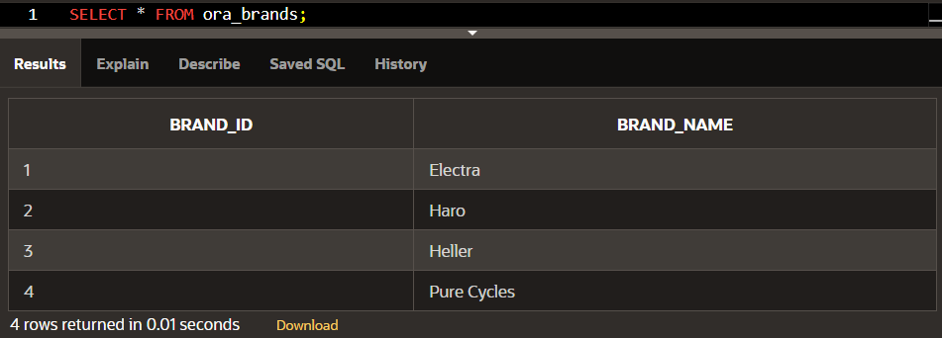

Stores:

-- Insert records into ora_stores

INSERT INTO ora_stores (store_id, store_name, phone, email, street, city, state, zip_code)

VALUES (111, 'Santa Bikes', '831-476-4321', 'santa@Keithsbikes.com', '3700 Portola Drive', 'Santa Cruz', 'CA', '95060');

INSERT INTO ora_stores (store_id, store_name, phone, email, street, city, state, zip_code)

VALUES (112, 'Cruz Bikes', '516-379-8888', 'Cruz@Keithsbikes.com', '4200 Chestnut Lane', 'Baldwin', 'NY', '11432');

INSERT INTO ora_stores (store_id, store_name, phone, email, street, city, state, zip_code)

VALUES (113, 'Scarlett Bikes', '972-530-5555', 'Scarlett@KeithsBikes.com', '8000 Fairway Avenue', 'Rowlett', 'TX', '75088');

Proof:

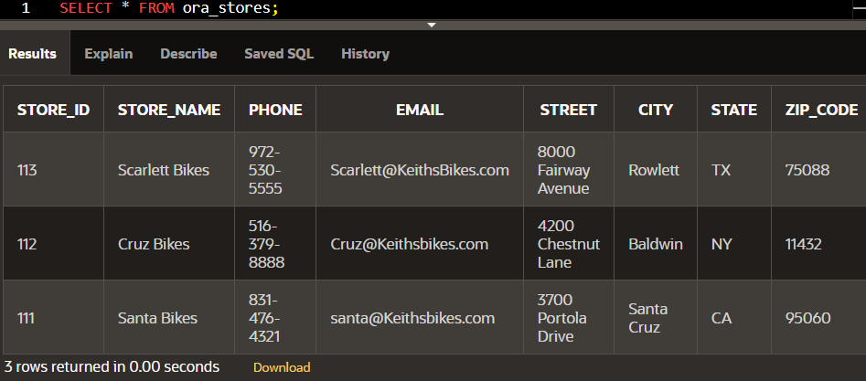

Categories:

-- Insert records into ora_categories

INSERT INTO ora_categories (category_id, category_name)

VALUES (11, 'Children Bicycles');

INSERT INTO ora_categories (category_id, category_name)

VALUES (12, 'Electric Bikes');

INSERT INTO ora_categories (category_id, category_name)

VALUES (13, 'Mountain Bikes');

INSERT INTO ora_categories (category_id, category_name)

VALUES (14, 'Road Bikes');

Proof:

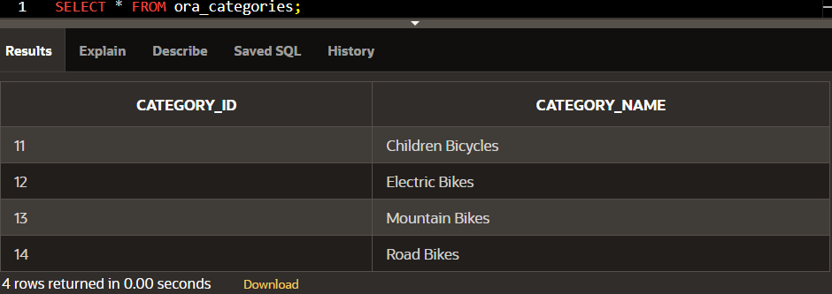

Products:

-- Insert records into ora_products

INSERT INTO ora_products (product_id, product_name, brand_id, category_id, model_year, list_price)

VALUES (1, 'Trek 820 - 2016', 2, 13, 2016, 379);

INSERT INTO ora_products (product_id, product_name, brand_id, category_id, model_year, list_price)

VALUES (2, 'Ritchey Timberwolf Frameset - 2016', 2, 13, 2016, 749.99);

INSERT INTO ora_products (product_id, product_name, brand_id, category_id, model_year, list_price)

VALUES (3, 'Surly Wednesday Frameset - 2016', 3, 13, 2016, 899);

INSERT INTO ora_products (product_id, product_name, brand_id, category_id, model_year, list_price)

VALUES (6, 'Sun Bicycles Streamway - 2017', 2, 12, 2017, 480);

INSERT INTO ora_products (product_id, product_name, brand_id, category_id, model_year, list_price)

VALUES (7, 'Sun Bicycles Cruz 7 - 2017', 4, 11, 2017, 420);

INSERT INTO ora_products (product_id, product_name, brand_id, category_id, model_year, list_price)

VALUES (8, 'Sun Bicycles Drifter 7 - Women''s - 2017', 4, 11, 2017, 479.99);

INSERT INTO ora_products (product_id, product_name, brand_id, category_id, model_year, list_price)

VALUES (9, 'Trek 820 - 2018', 4, 14, 2018, 380);

INSERT INTO ora_products (product_id, product_name, brand_id, category_id, model_year, list_price)

VALUES (10, 'Trek Marlin 5 - 2018', 4, 14, 2018, 450);

Proof:

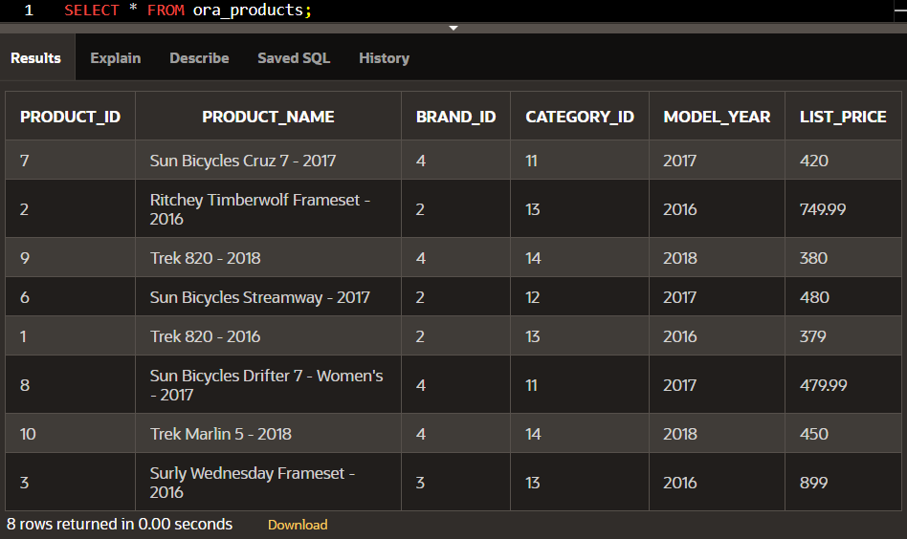

1. Add an index on the email column for the Customers table. We used:

CREATE INDEX idx_customer_email ON ora_customers (email);

Proof:

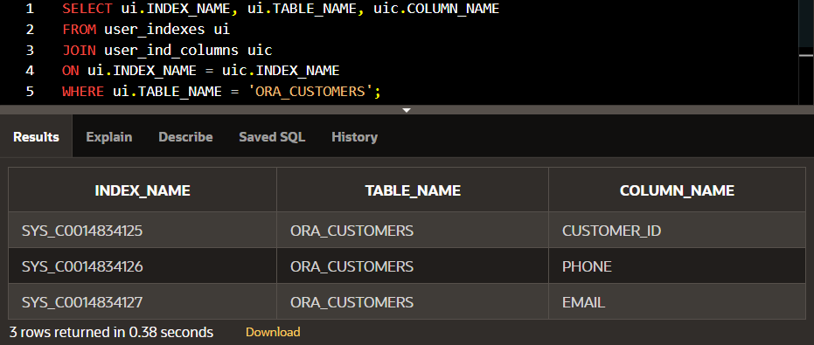

1. Create a view. We used:

CREATE VIEW vw_staff_store_orders AS

SELECT

s.first_name || ' ' || s.last_name AS staff_name,

st.store_name,

o.order_id

FROM ora_staffs s

JOIN ora_orders o ON s.staff_id = o.staff_id

JOIN ora_stores st ON s.store_id = st.store_id

WHERE o.order_status != 4 -- Exclude completed orders

WITH READ ONLY;

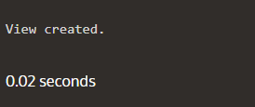

For the view to show data, we first have to have data. Below are the sample data that was inserted:

For ora_staffs:

INSERT INTO ora_staffs (staff_id, first_name, last_name, email, phone, store_id)

VALUES (2001, 'Alice', 'Johnson', 'alice.johnson@santabikes.com', '123-456-7890', 111);

INSERT INTO ora_staffs (staff_id, first_name, last_name, email, phone, store_id)

VALUES (2002, 'Bob', 'Williams', 'bob.williams@cruzbikes.com', '987-654-3210', 112);

INSERT INTO ora_staffs (staff_id, first_name, last_name, email, phone, store_id)

VALUES (2003, 'Claire', 'Smith', 'claire.smith@scarlettbikes.com', '456-789-0123', 113);

For ora_customers:

INSERT INTO ora_customers (customer_id, first_name, last_name, phone, email, street, city, state, zip_code)

VALUES (1001, 'John', 'Doe', '123-456-7890', 'john.doe@example.com', '123 Main St', 'Springfield', 'IL', '62701');

INSERT INTO ora_customers (customer_id, first_name, last_name, phone, email, street, city, state, zip_code)

VALUES (1002, 'Jane', 'Smith', '987-654-3210', 'jane.smith@example.com', '456 Elm St', 'Chicago', 'IL', '60616');

INSERT INTO ora_customers (customer_id, first_name, last_name, phone, email, street, city, state, zip_code)

VALUES (1003, 'Mike', 'Brown', '555-123-4567', 'mike.brown@example.com', '789 Oak St', 'Houston', 'TX', '77001');

INSERT INTO ora_customers (customer_id, first_name, last_name, phone, email, street, city, state, zip_code)

VALUES (1004, 'Sara', 'Johnson', '555-987-6543', 'sara.johnson@example.com', '321 Pine St', 'Seattle', 'WA', '98101');

For ora_orders:

INSERT INTO ora_orders (order_id, customer_id, order_status, order_date, required_date, shipped_date, store_id, staff_id)

VALUES (3001, 1001, 1, TO_DATE('2024-12-05', 'YYYY-MM-DD'), TO_DATE('2024-12-10', 'YYYY-MM-DD'), NULL, 111, 2001); -- Pending

INSERT INTO ora_orders (order_id, customer_id, order_status, order_date, required_date, shipped_date, store_id, staff_id)

VALUES (3002, 1002, 2, TO_DATE('2024-12-01', 'YYYY-MM-DD'), TO_DATE('2024-12-06', 'YYYY-MM-DD'), TO_DATE('2024-12-05', 'YYYY-MM-DD'), 112, 2002); -- Processing

INSERT INTO ora_orders (order_id, customer_id, order_status, order_date, required_date, shipped_date, store_id, staff_id)

VALUES (3003, 1003, 3, TO_DATE('2024-12-02', 'YYYY-MM-DD'), TO_DATE('2024-12-08', 'YYYY-MM-DD'), NULL, 113, 2003); -- Rejected

INSERT INTO ora_orders (order_id, customer_id, order_status, order_date, required_date, shipped_date, store_id, staff_id)

VALUES (3004, 1004, 4, TO_DATE('2024-12-03', 'YYYY-MM-DD'), TO_DATE('2024-12-09', 'YYYY-MM-DD'), TO_DATE('2024-12-08', 'YYYY-MM-DD'), 113, 2003); -- Completed

And more data but it will be too long to include.

Proof:

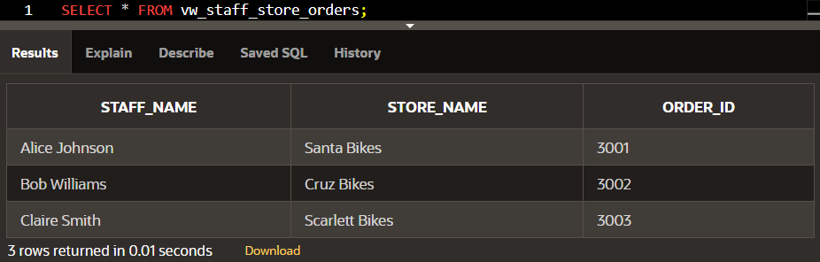

1. Create a synonym for the View created in (3e). We used:

CREATE SYNONYM syn_staff_store_orders FOR vw_staff_store_orders;

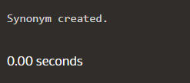

Proof:

